IP Addressing
Objective:
To learn how setup a system on the network.
Reading:
Chapter 12 of the textbook and the workbook that is posted on my website
Assignments:
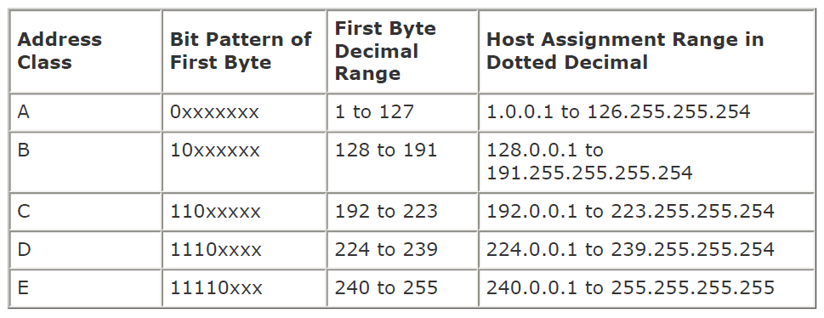

The above the is the IPv4 Address Table for defining networking classes. Use that information when answering the following questions from the workbook.

- Answer the LAST 5 questions on page 3 of the workbook
- Answer the LAST 5 questions on page 4 of the workbook
- Answer the LAST 5 questions on page 5 of the workbook
- Answer the LAST 5 questions on page 6 of the workbook
- Answer the LAST 5 questions on page 7 of the workbook

